Design and Development of an AI-Enabled Web-Based Eyewear Inventory and E-Commerce Management System (iWear) with an AI Business Insights Assistant
MSc Masters Project Specification
Supervisor: Tariq Alsboui Date: 17-Feb-2026

1. Abstract
The rapid advancement of digital technologies and e-commerce platforms has significantly transformed modern retail operations. Small and medium-sized enterprises (SMEs) increasingly rely on web-based systems to manage inventory, sales, and customer relationships. Despite this shift, many optical and eyewear retailers still depend on manual processes or basic spreadsheet-based solutions, which result in inefficiencies, data inaccuracies, poor stock control, and limited visibility of business performance.
This project proposes the design and development of an AI-enabled web-based Eyewear Inventory and E-Commerce Management System, named iWear. The system integrates inventory management, product catalog management, online ordering using a cash-on-delivery model, and eyewear-specific customization, including frame selection, lens options, and prescription data input. In addition, the system includes an AI Business Insights Assistant that allows store owners to retrieve business reports such as daily sales, profit, and best-selling products using natural-language queries.
The project will adopt an iterative and incremental development methodology encompassing requirements analysis, system design, implementation, testing, and evaluation. Modern web technologies will be employed to ensure scalability, usability, and security. The expected outcome is a functional prototype that demonstrates the effective application of computing and artificial intelligence techniques to address real-world challenges faced by eyewear retailers.
In addition to inventory management, the iWear system incorporates a customer-facing e-commerce module that supports eyewear-specific customisation, including frame selection, lens options, and prescription data input. Furthermore, the system integrates an AI Business Insights Assistant designed to provide store owners with accessible business intelligence through natural-language queries. Together, these components form a unified platform that supports operational efficiency, customer experience, and data-driven decision-making within the eyewear retail domain.

3. Justification and Overall Aim

3.1 Justification
Modern web-based retail systems are increasingly developed as multi-module applications, where different components such as inventory management, e-commerce functionality, and analytics are implemented separately. While this modular approach offers flexibility and scalability, it also introduces significant integration challenges. When system components are developed independently, inconsistencies in data handling, application programming interface (API) communication, and error management can arise. Such integration failures may result in incorrect business data, system crashes, or unexpected behaviour, all of which negatively impact system reliability.
In the context of eyewear retail, reliable system integration is particularly important due to the interdependence between system modules. Inventory data must remain synchronised with order processing, prescription handling, and reporting components. Any breakdown in communication between these modules can lead to inaccurate stock levels, incorrect order fulfilment, or misleading business insights. For small and medium-sized enterprises (SMEs), these issues can significantly disrupt daily operations and reduce customer confidence.
Security represents another critical concern for web-based retail systems. Weak authentication mechanisms, inadequate access control, and insecure data transmission expose systems to unauthorised access and potential data breaches. Eyewear retail systems often handle sensitive information, including prescription details and order-related data, which must be protected to maintain customer trust and comply with ethical data-handling standards. Without appropriate security controls, even well-designed functional systems may be unsuitable for real-world deployment.
Testing is frequently underemphasised in small-scale and academic projects, despite its importance in ensuring system stability and security. Without structured integration and system-level testing, defects related to module interaction or security vulnerabilities may remain undetected until system deployment. This can result in unreliable system behaviour and increased maintenance effort.
The justification for this individual project component lies in the need to address these challenges through a focused approach to system integration, security implementation, and comprehensive testing. By applying structured integration strategies, implementing secure access controls, and conducting systematic testing, this component aims to ensure that the iWear system operates as a cohesive, secure, and reliable platform suitable for eyewear retail environments.
Recent research in web application security emphasises that integration failures and improper access control remain primary causes of system vulnerabilities in SME environments. Studies on secure software engineering highlight that inadequate role separation and weak API protection significantly increase the likelihood of unauthorised access and data inconsistencies. While enterprise systems often implement structured security audits, SMEs typically lack formalised security evaluation processes. This reinforces the need for structured security-by-design implementation and systematic integration testing within SME-focused systems such as iWear.

3.2 Overall Aim
The overall aim of this individual project component is to design, implement, and empirically evaluate secure integration and access control mechanisms within the iWear system in order to enhance system reliability, enforce structured role-based authorisation, and ensure secure interaction between system modules.

4. Objectives
The objectives of this individual project component are structured to be specific, measurable, achievable, relevant, and time-bound (SMART). Together, they support the secure integration, testing, and reliable operation of the iWear system.
The first objective is to design secure authentication and authorisation mechanisms for the system. This involves ensuring that users are properly verified before accessing system functionalities and that only authorised users can perform sensitive operations. Successful completion of this objective is demonstrated through secure login and access control implementation.
The second objective is to implement role-based access control (RBAC) for different system users. This objective ensures that administrative users, operational staff, and other roles have access only to the features relevant to their responsibilities. Role separation improves system security and reduces the risk of unauthorised actions.
Another objective is to ensure reliable integration between frontend interfaces, backend services, and the database layer. This involves verifying consistent data flow across system components and ensuring that changes in one module are accurately reflected across the system. Reliable integration is assessed through integration testing and system validation.
The project also aims to secure API endpoints and data transmission mechanisms. This objective focuses on preventing unauthorised access to backend services and protecting data exchanged between system components. Secure API access contributes to system integrity and confidentiality.
In addition, the project seeks to design and execute integration and system-level test cases. These tests validate functional correctness, module interaction, and error handling under realistic usage scenarios.
Another objective is to identify and mitigate potential security vulnerabilities within the system. This includes assessing common threats such as improper access control, insecure data handling, and configuration weaknesses.
Finally, the project aims to evaluate system reliability and robustness under different usage scenarios, including concurrent operations. This objective is measured through testing outcomes that demonstrate stable and secure system behaviour.

5. Literature Review
Web application security has become a major area of research due to the rapid growth of online systems and the increasing frequency of cyber threats. Modern web applications often handle sensitive operational and user-related data, making them attractive targets for unauthorised access and malicious attacks. Research consistently identifies common vulnerabilities such as insecure authentication mechanisms, improper access control, insufficient input validation, and weak session management. These vulnerabilities can lead to data breaches, system compromise, and loss of user trust if not adequately addressed.
Studies emphasise that implementing established security best practices significantly reduces the likelihood of successful attacks. Secure authentication mechanisms form the foundation of web application security by ensuring that only legitimate users can access system resources. Authentication techniques such as password hashing, session management, and token-based approaches are widely adopted to protect user identities and system functionality. Authorisation mechanisms further restrict access by defining what authenticated users are permitted to do within the system.
Role-based access control (RBAC) is frequently highlighted in the literature as an effective authorisation strategy for multi-user systems. RBAC assigns permissions based on user roles rather than individual identities, simplifying access management and reducing the risk of privilege misuse. Research suggests that RBAC not only enhances security but also improves system usability by ensuring that users are presented only with features relevant to their responsibilities. This approach is particularly suitable for retail systems, where different users such as administrators, staff, and managers require varying levels of access.
Beyond security mechanisms, system integration has emerged as a critical challenge in modern web application development. Multi-module systems often consist of independently developed components that must interact reliably. Literature on software architecture highlights that poor integration practices can lead to data inconsistencies, communication failures, and unpredictable system behaviour. In retail environments, such failures may result in incorrect stock levels, inaccurate reports, or failed transactions, all of which negatively affect business operations.
Software testing research places strong emphasis on the importance of integration testing and system-level testing in multi-component applications. Unit testing alone is insufficient to ensure overall system reliability, as many defects arise from interactions between components rather than within individual modules. Integration testing verifies that system components communicate correctly, while system testing evaluates the behaviour of the complete application under realistic conditions. Studies suggest that early detection of integration issues significantly reduces development cost and improves long-term system quality.
Security testing is also a critical aspect of reliable system development. Vulnerability assessments and security-focused testing help identify weaknesses related to authentication, access control, and data handling. Research indicates that incorporating security testing into the development lifecycle is more effective than treating security as an afterthought. This approach aligns with secure-by-design principles, which advocate integrating security considerations throughout system development.
Despite extensive research on web application security and software testing, relatively limited attention has been given to small-scale, multi-module retail systems developed under resource constraints. Many academic studies and industry frameworks focus on large enterprise systems with dedicated security teams and extensive testing resources. However, small and medium-sized enterprises often lack the expertise, time, and budget required to implement complex security solutions.
In SME environments, lightweight and practical security strategies are often more appropriate than comprehensive enterprise-level frameworks. Research suggests that focusing on core security principles—such as secure authentication, role-based access control, and controlled API access—can provide meaningful protection without excessive complexity. Similarly, structured integration and system testing can significantly improve reliability even when development resources are limited.
This project builds upon existing literature on web application security, system integration, and software testing by applying established best practices within an integrated eyewear retail system. By focusing on secure authentication, role-based access control, reliable module integration, and systematic testing, the project addresses a gap in the literature related to SME-focused retail systems. The reviewed literature supports the view that applying well-established security and testing principles in a structured and context-aware manner can significantly enhance system reliability and trustworthiness, even within constrained development environments.
Empirical studies in web security research consistently demonstrate that improper access control is among the most critical vulnerabilities in modern applications. The OWASP Top 10 identifies broken access control as a leading risk category, particularly in multi-user systems. Research further indicates that role-based access control (RBAC), when properly implemented and tested, significantly reduces privilege escalation risks and simplifies permission management in multi-role environments. However, literature also highlights that RBAC effectiveness depends on rigorous validation and enforcement testing rather than mere implementation.
Integration testing research emphasises that many system failures arise not from individual module defects but from inter-module communication breakdowns. In multi-tier architectures, inconsistencies between frontend validation, backend logic, and database constraints may create exploitable weaknesses. Therefore, structured integration and system-level testing are essential to ensure stable and secure operation.

6. Methodology
An iterative and incremental development methodology is adopted for system integration, security implementation, and testing within the iWear system. This methodology is particularly suitable for multi-module web applications, as it allows system components to be integrated and evaluated progressively rather than as a single final step. By following an incremental approach, integration issues and security weaknesses can be identified and resolved early, reducing overall system risk and improving reliability.
The iterative process supports continuous refinement based on testing outcomes and observed system behaviour. This is especially important for retail systems, where multiple components—including inventory management, e-commerce functionality, and AI-based reporting—must interact reliably to ensure accurate data flow and stable operation.

6.1 System Integration
System integration focuses on ensuring consistent and reliable data flow between frontend interfaces, backend services, and the database layer. The iWear system follows a three-tier architecture, where frontend components communicate with backend services, which in turn interact with the database. Integration efforts are aimed at ensuring that data exchanged between these layers remains accurate, timely, and consistent.
RESTful application programming interfaces (APIs) are used to facilitate communication between system components. These APIs define structured endpoints for operations such as retrieving product data, processing orders, and updating inventory records. Each API endpoint is designed with clear input and output specifications to minimise ambiguity and reduce the likelihood of integration errors.
Integration testing is conducted to verify that API endpoints function correctly under normal and edge-case conditions. Test cases assess request handling, response accuracy, and error management. Special attention is given to scenarios where multiple system modules interact simultaneously, such as order placement triggering inventory updates and report generation. Successful integration is measured by consistent system behaviour and accurate data synchronisation across modules.

6.2 Security Implementation
Security implementation is a core focus of this project component due to the sensitive nature of retail and prescription-related data handled by the system. Authentication mechanisms are implemented to verify user identities before granting access to system features. Secure login procedures ensure that only authorised users can access system resources.
Role-based access control (RBAC) is applied to restrict access based on user roles. Different system users, such as administrators and operational staff, are granted permissions aligned with their responsibilities. This approach minimises the risk of unauthorised actions and reduces potential damage caused by compromised accounts.
Secure password storage techniques, such as hashing, are used to protect user credentials. Passwords are never stored in plain text, reducing the risk of credential exposure in the event of a data breach. In addition, controlled API access mechanisms are implemented to prevent unauthorised requests to backend services.
Data transmission between frontend and backend components is secured to protect sensitive information during communication. These security measures collectively contribute to system confidentiality, integrity, and availability, aligning with established web security best practices.

6.3 Testing Strategy
A comprehensive testing strategy is employed to evaluate system integration, security, and overall reliability. Testing is conducted at multiple levels to ensure that both individual components and the complete system function as intended.
Integration testing focuses on validating interactions between system modules. Test cases are designed to verify that data flows correctly between frontend interfaces, backend services, and the database. These tests help identify issues related to data inconsistency, API failures, or incorrect module interaction.
System testing evaluates the behaviour of the complete application under realistic usage conditions. Test scenarios simulate common user activities, such as logging in, placing orders, updating inventory, and generating reports. The system is assessed for stability, performance, and error handling during these operations.
Security testing is conducted to identify potential vulnerabilities related to authentication, authorisation, and data handling. Tests assess whether access controls are enforced correctly and whether unauthorised users are prevented from accessing restricted features. Common security risks, such as improper access control and insecure endpoints, are evaluated within the project’s academic scope.

6.4 Evaluation of Reliability and Robustness
System reliability and robustness are evaluated by testing the system under different usage scenarios, including concurrent operations. These tests assess how the system behaves when multiple users perform actions simultaneously, such as processing orders or updating inventory. Robust system behaviour is indicated by consistent performance and accurate data handling without system crashes or errors.
Testing outcomes are documented and analysed to identify system limitations and areas for improvement. This evaluation ensures that the system meets its defined objectives related to security, integration, and reliability.

6.5 Ethical and Practical Considerations
The system processes sensitive operational and prescription-related data, requiring careful handling. Ethical considerations include restricting access to authorised users only and ensuring that data is used strictly for functional and academic purposes. No unnecessary personal data is collected beyond system requirements.
Practical constraints, such as limited development time and academic scope, influence testing depth. Advanced penetration testing and enterprise-level security audits are outside the scope of this project. However, the implemented security and testing strategies provide a realistic and appropriate level of protection for an academic prototype.

6.6 Summary of Methodological Approach
Overall, the methodology combines iterative development with structured integration, security implementation, and comprehensive testing. By focusing on reliable module interaction, secure access control, and systematic evaluation, this project component ensures that the iWear system operates as a cohesive, secure, and dependable platform suitable for eyewear retail environments.

6.7 Measurable Security Evaluation Criteria
Security effectiveness will be evaluated using measurable benchmarks, including:
• 0% success rate of unauthorised access attempts during controlled testing
• 100% enforcement of RBAC restrictions across defined user roles
• Successful validation of all protected API endpoints against unauthorised requests
• Stable system behaviour under concurrent operations without privilege escalation
These criteria ensure empirical validation of security controls rather than reliance on theoretical implementation.

7. System Design
The system will follow a three-tier architecture consisting of:
- Presentation Layer: React-based frontend interface
- Application Layer: Python-based backend services
- Data Layer: PostgreSQL relational database

7.1 Module Descriptions
- Inventory Management Module: Manages products, stock updates, and low-stock alerts.
- Eyewear Customization Module: Handles frame selection, lens selection, and prescription entry.
- Order Management Module: Manages cart operations, order placement, and order history.
- AI Business Insights Module: Processes natural-language queries and generates business reports.

7.2 Security and Data Management
Security is a critical aspect of web-based systems. The proposed system will implement user authentication and role-based access control to restrict system access. Sensitive information such as user credentials will be securely stored using hashing techniques. Database access will be controlled through secure API endpoints to prevent unauthorized access.
Data integrity will be maintained through validation mechanisms and transaction management. Regular backups will be considered to minimize the risk of data loss.

8. Evaluation Strategy
The system will be evaluated against predefined integration and security benchmarks. Evaluation will measure successful RBAC enforcement, prevention of unauthorised API access, correct module interaction under concurrent operations, and absence of integration-induced data inconsistencies.
Results will be analysed to determine whether structured security mechanisms and integration testing improve system reliability compared to non-structured implementations. Identified limitations will be critically discussed to support future enhancements.

9. Work Plan
This work plan emphasises system security and reliability. Early stages focus on identifying security risks and defining authentication and access control mechanisms. API security ensures safe data exchange between system components.
Integration and security testing validate system robustness under realistic conditions. The final evaluation phase ensures compliance with ethical and security best practices.
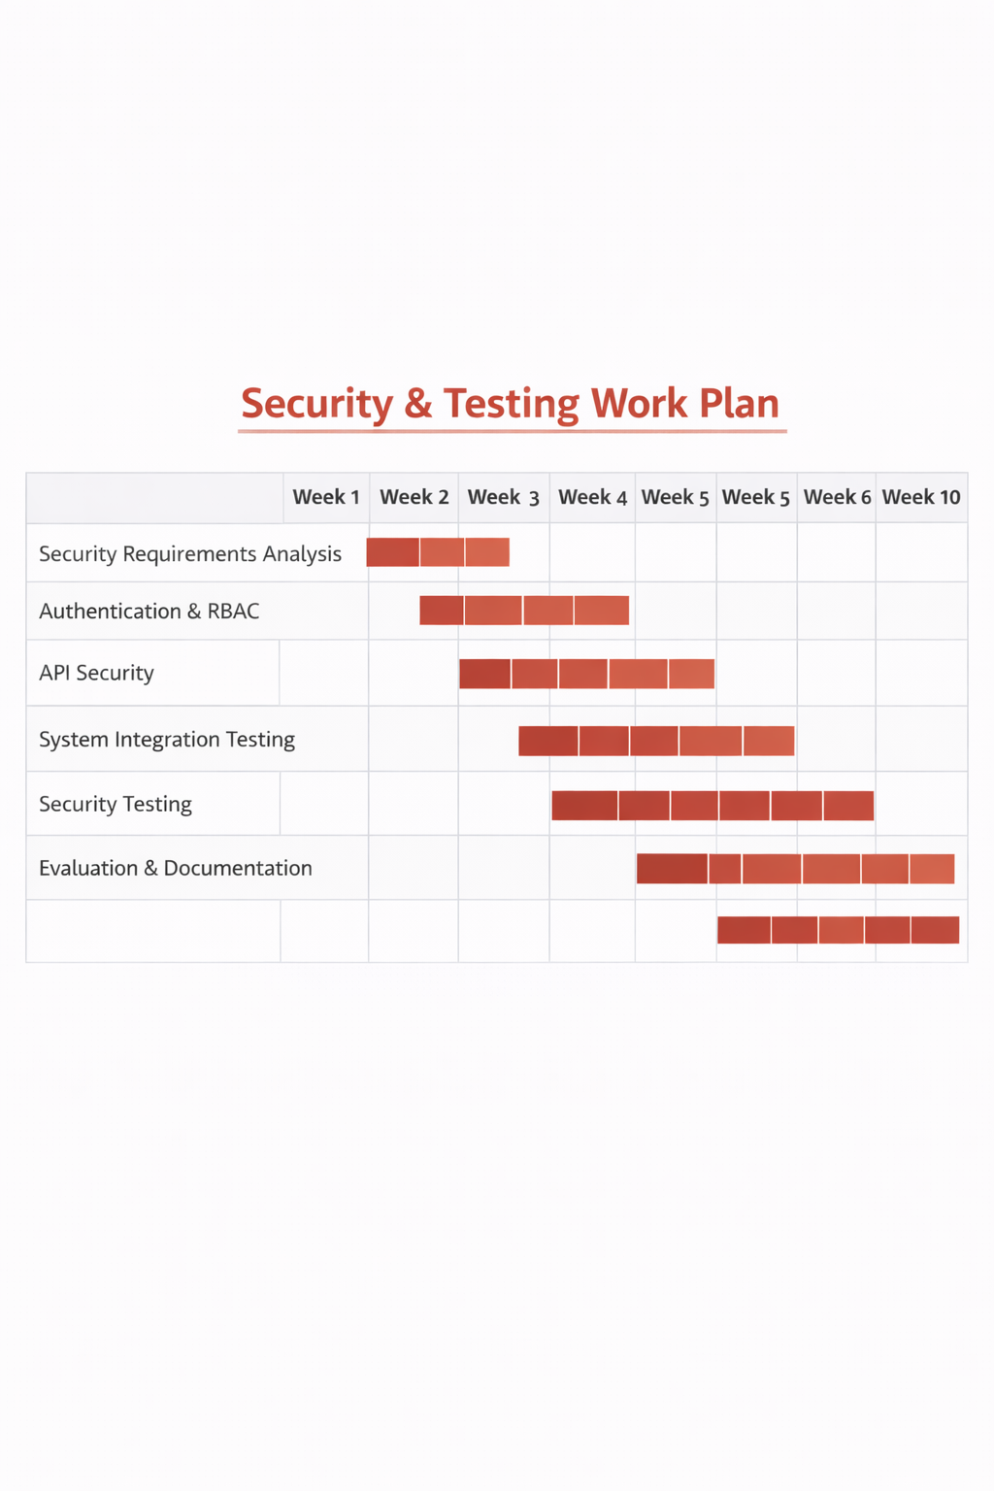

10. Ethical Considerations
The system handles prescription and order-related data, which requires secure storage and controlled access. Ethical guidelines for data protection will be followed, and access to sensitive information will be limited to authorised users only.

11. Risks and Limitations
Potential risks include integration conflicts between modules and overlooked security vulnerabilities. These risks will be mitigated through structured testing and adherence to established security practices. Due to academic time constraints, advanced penetration testing is outside the project scope.

12. Conclusion
This individual component focuses on ensuring the secure and reliable operation of the iWear system. By addressing integration, security, and testing concerns, the project aims to deliver a stable platform suitable for real-world eyewear retail environments.

References
(Harvard – Cite Them Right)
OWASP Foundation (2023) OWASP Top 10 Web Application Security Risks. Available at: https://owasp.org (Accessed: 15 January 2026).
Chaffey, D. (2019) Digital Business and E-Commerce Management. 7th edn. Harlow: Pearson Education.
Heizer, J., Render, B. and Munson, C. (2020) Operations Management: Sustainability and Supply Chain Management. 13th edn. Harlow: Pearson.
Laudon, K.C. and Traver, C.G. (2021) E-Commerce: Business, Technology, Society. 16th edn. Harlow: Pearson Education.
Turban, E., Pollard, C. and Wood, G. (2018) Information Technology for Management: On-Demand Strategies for Performance, Growth and Sustainability. 11th edn. Hoboken: Wiley.
Chen, H., Chiang, R.H.L. and Storey, V.C. (2012) ‘Business Intelligence and Analytics: From Big Data to Big Impact’, MIS Quarterly, 36(4), pp. 1165–1188.
Rouse, M. (2020) Inventory Management System. Available at: https://www.techtarget.com (Accessed: 15 January 2026).
PostgreSQL Global Development Group (2024) PostgreSQL Documentation. Available at: https://www.postgresql.org/docs/ (Accessed: 15 January 2026).
Flask Documentation (2024) Flask Web Framework. Available at: https://flask.palletsprojects.com (Accessed: 15 January 2026).
React Documentation (2024) React – A JavaScript Library for Building User Interfaces. Available at: https://react.dev (Accessed: 15 January 2026).

